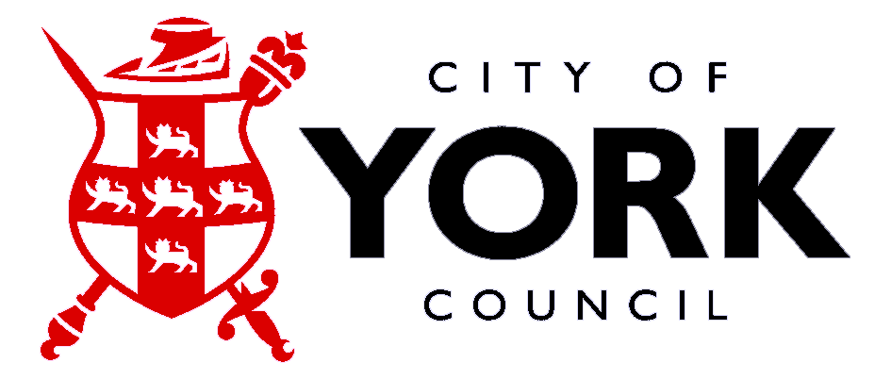
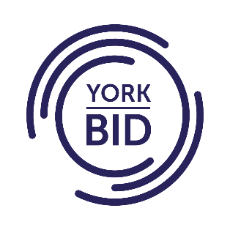
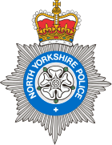

We are writing to you regarding concerns raised to us relating to nuisance behaviour in York City Centre. This includes street drinking, anti-social behaviour, littering, disruptive noise, lewd behaviour, violence and verbal abuse.
North Yorkshire Police, City of York Council and York BID are committed to keeping the streets of York safe and have launched ‘Operation Vault’ which aims to reduce these issues and the impact they have on the residents, businesses and tourists to York.
We recognise that you may be the victim of crime and anti-social behaviour, and encourage you to continue to report incidents which enables us to both support you as a victim, and to understand the current picture in the City to better deploy resources.
We have created this Business & Retail Crime Prevention Pack to help keep businesses safe, we hope you find it useful. You can also find the resources on the National Business Crime Centre website: https://nbcc.police.uk
We would also like to take this opportunity to remind you of your obligations under the Licensing Act 2003 regarding the sale of alcohol namely:
Section 141 of The Licensing Act 2003 ‘Selling to people who are drunk’ which states:
Sale of alcohol to a person who is drunk
  - A person to whom subsection (2) applies commits an offence if, on relevant premises, he knowingly—
sells or attempts to sell alcohol to a person who is drunk, or
allows alcohol to be sold to such a person.

This applies to:-
- Any person who works at the premises in a capacity that gives him the authority to sell the alcohol
- A premises licence holder or
- A designated premises supervisor
A person guilty of this offence under this section is liable on summary conviction to a fine not exceeding Level 3 (£1000).
Premises should also take steps to promote the four Licensing Objectives:-
- The Prevention of Crime and Disorder
- Prevention of Public Nuisance
- Public safety
- Prevention of Children from Harm

North Yorkshire Police are using SentrySIS - https://sentrysis.com/ which is an information sharing platform as part of the York Business Against Crime Scheme. This can be useful for businesses to see who is prolifically causing issues in York.
We are also asking that you sign up to North Yorkshire Community Messaging which is a free email messaging service from North Yorkshire Police which provides news and updates on policing matters that are relevant to you and your local community. You can reply directly to your neighbourhood team and provide feedback via surveys.
https://www.northyorkshirecommunitymessaging.co.uk/#SignUp
Alternatively, if you would like to report anything anonymously, please contact Crimestoppers –
0800 555 111.
We look forward to working with you to make York a safer place for all to live and work.

